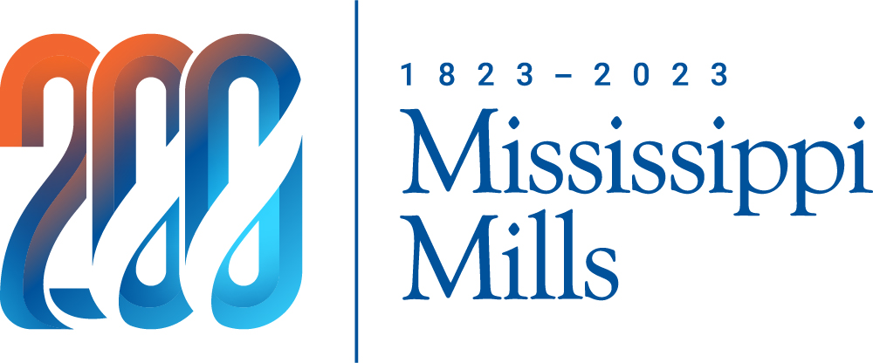

Municipality of Mississippi Mills
3131 Old Perth Road
PO Box 400
Almonte ON K0A 1A0

Neighbourhood Micro Grant

Application Form

Mississippi Mills recognizes the value of building an inclusive, welcoming, and fun community. In recognition of this and, in celebration of the Bicentennial, the municipality has committed $3600______ in 2023 to provide micro-grants of up to $200 to encourage residents to get out, meet each other, and celebrate!

Eligibility Criteria
- Your project must be accessible and welcoming to all.
- Except for community gardens, projects involving infrastructure building, upgrading or maintenance are not eligible.
- You must begin your project after the grant decision is made. Projects are not supported retroactively.
- Preference will be given to new projects, or those that have been funded for fewer than three years in a row.

WHO IS NOT ELIGIBLE
- Applicants who profit financially from the project.
- Registered organizations and businesses.
- Applicants that have already received funding through the municipality.
- Organizations with political affiliations.

A. Applicant #1 (Requires 2 Organizers from different households)
Name:

Mailing Address: (Must be a resident of Mississippi Mills)

Telephone: _________________________________________

E-mail: _________________________________________
*(check off one name only) name)

Cheque to be made out to this applicant.

B. applicant #2 (requires 2 organizers from different households)
Name:

Mailing Address: (Must be a resident of Mississippi Mills)

B. applicant #2 (continued)

Telephone: _________________________________________

E-mail: _________________________________________
*(check off one name only) name)

Cheque to be made out to this applicant.

*Both applicants are responsible for managing the event and the grant money but only one name will be listed on the cheque.

C. Event Details
Title:
Date:
Location:

Events held in public spaces (neighbourhood streets or parks) must follow municipal by-laws and may require liability insurance, depending on the nature of the event.
Brief Description: (include # of people invited & how you plan to be inclusive)

Municipal Resources: (available on a first come, first served basis)
Indicate what resources you would like to use, if available:
#
# of Tents
# of Tables

# of Chairs
# of Garbage Cans

Other Resources: Eastern Ontario Event Centre www.almontecivitan.com/our-services/eastern-ontario-event-centre/

D. Draft Budget (details on how the grant money will be used)
Please consider the following when calculating your project budget:
- Think resourcefully. Where possible obtain materials through borrowing or donations.
- Grant money can be used to pay people (honorarium) for services ie. paying someone to lead a workshop or for carpentry work. Maximum allowable amount $50/person.

Note: If you receive a grant, you are responsible for keeping expense receipts.

E. Event Category

Micro Grants are available for residents to develop projects that meet the needs of their neighbourhood community. Please indicate which goal your event hopes to achieve.

Connect and engage neighbourhood residents of all ages and abilities.
Examples: block parties to introduce new residents, weekly neighbourhood clean-up work parties that strengthen and sustain relationships over time, a birthday party for the oldest person on our street.

Share residents’ skills and knowledge within the community.
Examples: FREE yoga lesson for the community, or a community kitchen where participants exchange their cooking skills and share a meal together or launch a secret Santa or cookie swap in your neighbourhood.

Build sense of ownership and pride.
Examples: A historical tour of the neighbourhood, a community clean-up of invasive species in a local green space, a snowman building festival.

Respect and celebrate diversity.
Examples: A multicultural fashion show, a storying telling project that involves seniors and youth, a cost-free acrylic workshop open to all ages and skill levels.

G. Timeline:
The deadline to submit your application is May 31, 2023.__

- We will acknowledge receipt of your application by e-mail.
- After the initial deadline, any remaining funds will be awarded to eligible projects on a first come, first served basis until all funds have been awarded.

Within 8 weeks of event completion, applicants must provide a written submission outlining: number of attendees, successes/challenges, event photos, sample communication/marketing materials, cost analysis, etc. Note: Stories and photos may be shared on the municipality’s website, with Millstone News and/or the Mississippi Mills Gazette/Carleton Place Canadian.

Any applicant that does not provide a written submission will be excluded from future funding.

H. Signature page:

______________________ ______________________
Signature (applicant #1) Signature (applicant #2)

______________________ ______________________
Date Date

Submission of your application does not guarantee award of a Community Micro Grant

Please refer to the Community Micro Grant Guidelines for more information

The personal information on this form is collected under the authority of the Municipal Act, 2001, S.O. 2001, c. 25, s. 8,9 and 11 and will be used to determine qualifications for a neighbourhood micro grant. Questions about this collection should be directed to the Manager of Community and Economic Development, 14 Bridge Street, Almonte, Ontario, K0A 1A0, (613)256-2064 ext. 602.

